About AI Installer

Click **5-AI Installer.bat** to Start.

It will list all the MOD version in **3 – MOD**

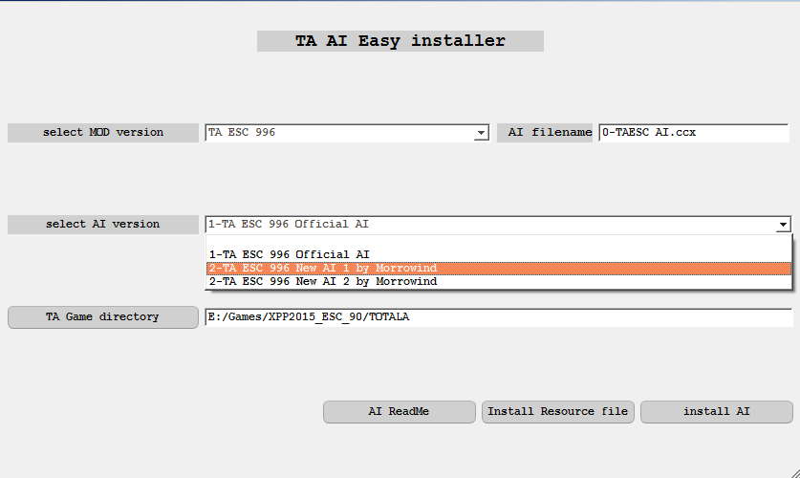

# About

The main idea of this AI installation method is to separate the data files and AI files in the MOD to achieve a convenient operation of changing AI schemes at any time.

Take the TA33B as an example

ta33b.33b file contains only data files

Split 1

In the TA33b MOD resource file “TA33b.33b” contains data file and AI file

Split 2

The installation replaces the file of the same name in the game directory with TA33B.33B, which only contains the data file, and copies TA33B AI.ufo to the game directory

**NOTES**

TA33B will conflict with TAAC 1.5(they are use same dirname in pack resources), please split two mod in different TA catalog. Or you can make sure there only one “MOD AI.ccx” in the game catalog.

# install_Config.properties

The configuration file is in the 0-TA_AI_Install directory

**#[]Square brackets represent the beginning of each configuration node**

[Mod_dir]

**#MOD DIR,The default is the 3-MOD directory**

mod_dir=3-MOD

[Mod_Source]

**#Resource folder,the default is 0-ModSource,0-TAUnitPic**

SourceDir=0-ModSource

PicDir=0-TAUnitPic

[Mod_SourceFile]

**#Resource file name, file in the 0-ModSource folder**

**#subfolder name in 3-MOD directory=MOD resource file name**

TA 33BN=ta33bn.33b

TAAC 1.5=acdata.acc

TA ESC 996=TAESC.gp3

[Mod_AiFile]

**#AI packed data file**

**#exists in every AI version directory (AI shcema 1, AI shcema 2)**

TA 33BN=0-TA33B AI.ccx

TAAC 1.5=0-TAAC 1.5 AI.ccx

TA ESC 996=0-TAESC AI.ccx